**1.1 I can describe what web site content and layout will be needed for each page.**  
My website will have 4 pages on it. The pages will be titled (i.e. on the navigation bar) as Home, The good, The bad, and Contact us. All buttons on the navigation bar will be in a teal colour when the user hovers their mouse over it, or is on that page. I will have the headings on every page in <h1> size and in a teal colour too. No page will be long or wide enough to need a scroll bar except if viewing on a small window.

The first page will be the home page.

Text size: normal size, h1 for heading

Navigation bar

Heading

Main content

Footer

Font: Google’s Sora font, otherwise sans-serif

Colour: heading is teal, text is black

An image of Malakai will be in the middle of the  
main content area under the heading. I will position it

at 50px or so from the top, and it will be sized in

relation to the window size – perhaps 30-40%,

depending on how much text I have on the page. I

will have help text on the page under this to tell the

user how to navigate my website.

The second will have images of my cat on it.

Navigation bar

Heading

Main content

Footer

Text size: normal size, h1 for heading

Font: Google’s Sora font, otherwise sans-serif

Colour: heading is teal, text is black

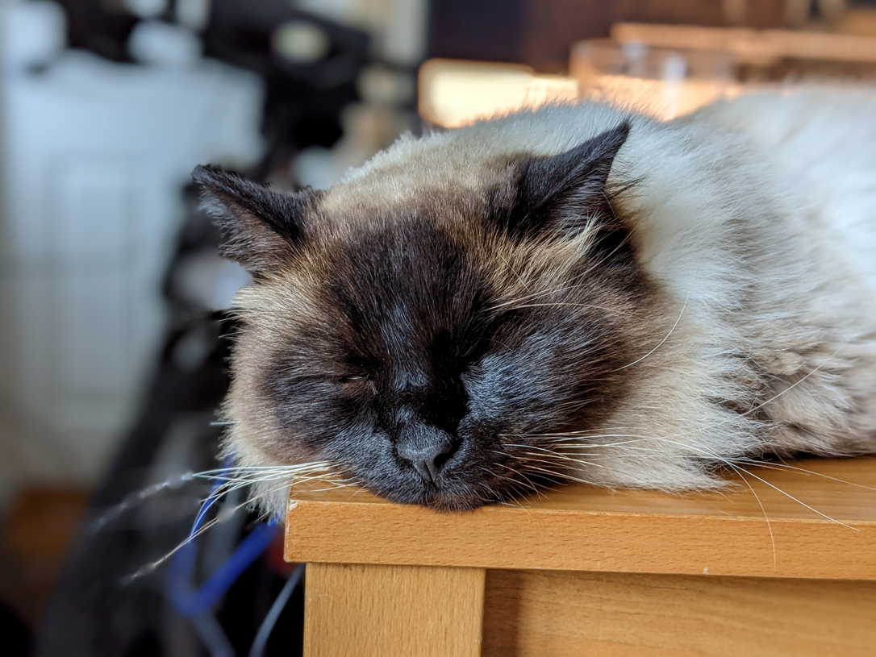 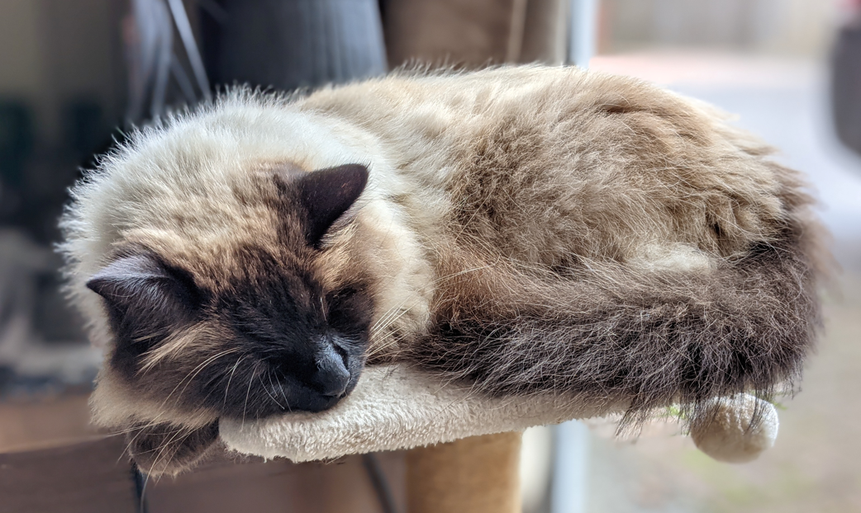

 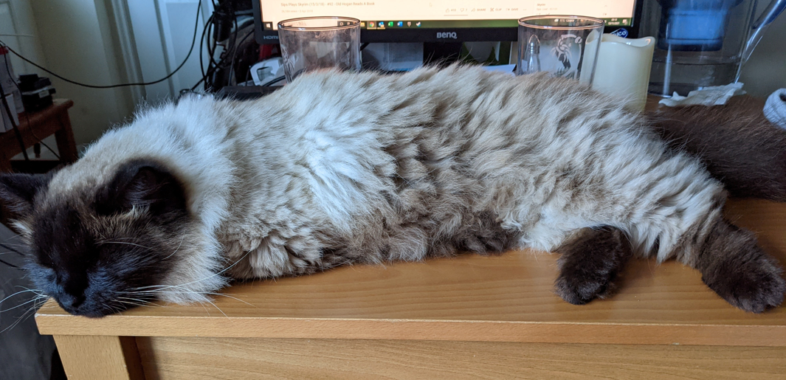

I will have these few pictures of Malakai and some text below it. I will give it a heading of **Malakai is adorable** and the pictures, like on the home page, will be sized depending on the space available. As I am using three pictures, centred and in a row, they will be sized around 30%, all the same distance from the top.

The third page will talk about the challenges of having

Navigation bar

Heading

Main content

Footer

our cat.

Text size: normal size, h1 for heading

Font: Google’s Sora font, otherwise sans-serif

Colour: heading is teal, text is black

Page 3 will have just text. The heading will be **Things aren’t always so easy** and, to satisfy requirements, I will have a list of my three favourite colours between the end of the relevant text and the footer.

The fourth page will be a contact us page with a form.

Navigation bar

Heading

Main content

Footer

Text size: normal size, h1 for heading

Font: Google’s Sora font, otherwise sans-serif

Colour: heading is teal, text is black

Page 4 will have text above and below a responsive

contact form. The heading will be just **Contacting** us.

I will amend the form example w3 schools provide on

their website so that it fits in with my style

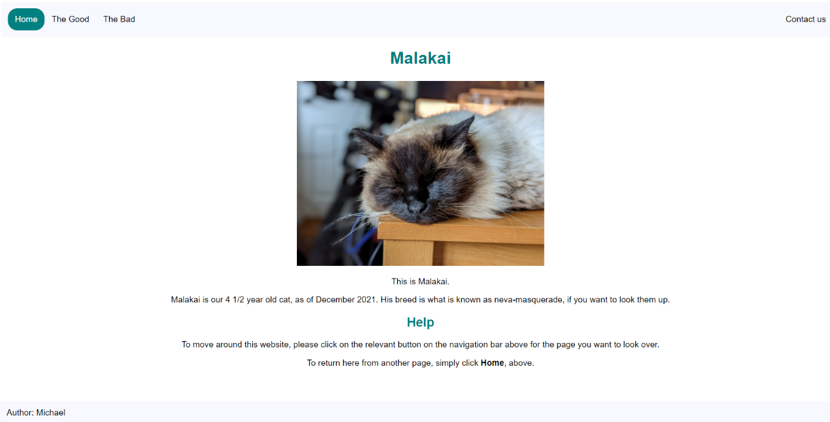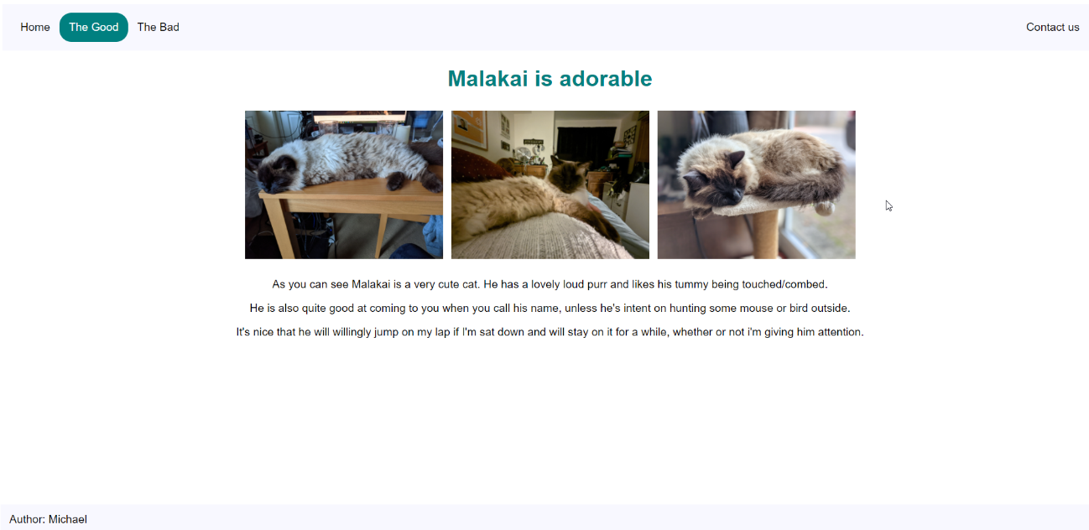**I can plan and create web page templates to layout**  
Here are my web pages that I produced based on my plan:  
  
  
 